Game Boy Memory Layout

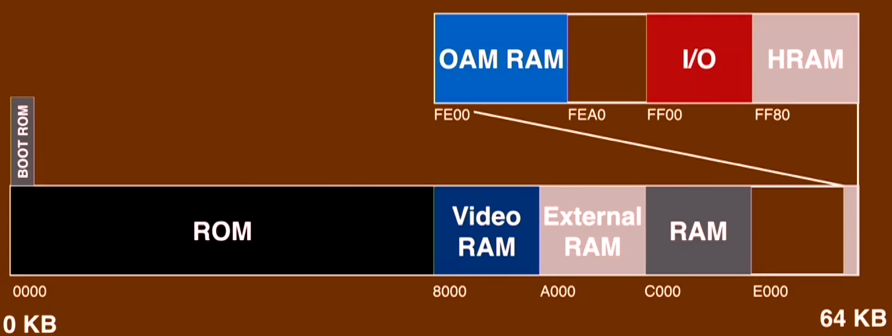
Memory Address | Name | Physical Location
$0000 - $00FF | Boot ROM | Built into CPU
$0100 - $3FFF | ROM Bank 0 (ROM0) | Cartridge
$4000 - $7FFF | ROM Bank 1 – n (ROMX) | Cartridge
$8000 - $9FFF | Video RAM | Built into Game Boy
$A000 - $BFFF | External RAM | Cartridge
$C000 - $DFFF | Work RAM (SRAM) | Built into Game Boy
$E000 - $FDFF | Copy of Work RAM | Built into Game Boy

Boot ROM:
256B of instructions built into the CPU of the Game Boy. Used to initialise the console and compare the Nintendo logo in the Boot ROM to the Nintendo logo in the cartridge for copyright and legal reasons.

ROM Bank 0 (ROM0):
16KB of memory located on the cartridge. This is where the header and game code goes. However, since memory addresses $0000 - $00FF are reserved for the Boot ROM, we cannot use those. So we actually only have 16KB - 256B worth of usable memory.

ROM Bank 1 - n (ROMX):
16KB of memory located on the cartridge. This is where the game code goes. Larger games may be greater than 32KB, but the 8-bit CPU can only address up to 64KB of memory. To get around this, it is possible to map this 32KB of memory address to different sections of the cartridge’s memory. For example if we have a larger game which takes up 128KB, we cannot access all 128KB at the same time, but we can access 16KB - 256B in ROM0, and another swappable 16KB in ROMX.

Copy of Work RAM:
A copy of the Work RAM. Any data in the Work RAM will be copied into this area and vice versa. It’s purpose is unknown. Game programmers should NOT use these memory addresses.

